Within the framework of the project Circular-Based Waste Management (The project is funded by Iceland, Liechtenstein and Norway through the EEA and Norway Grants Fund for Regional Cooperation), a survey in the basic schools of the city of Paide was conducted between 17.11.2020 and 4.12.2020.
A total of 434 students participated in the survey (ie 66% of the total number of students)
Grade (class) 4.-6. 242 students, ie 71% (total number of students in this age is 343)
Grade 7.-9. 192 students, ie 60% (total number of students in this age is 316)
The following is an overview of the responses by age group.

The students are divided into two age groups due to the fact that the project lasts for three years, during which time the students participate in various activities aimed at raising their awareness of the issues of recycling. By the end of the project (July 2023), 4-6 people have participated in this survey. students of the 7th-9th grade. classes and a second survey is conducted to compare the Project.

1. To your knowledge, what type of waste is it possible to recycle? (4-6 class)

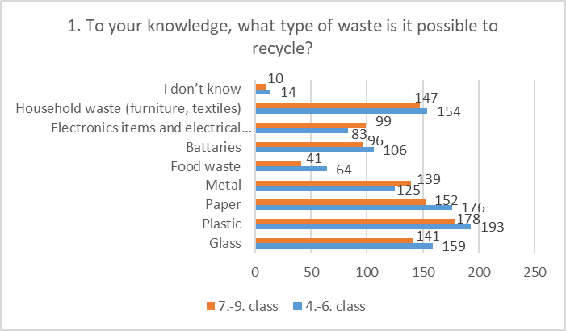

Almost 6% of students in grades 4-6 do not know what kind of waste can be recycled.

Almost 5% of students in grades 7-9 do not know what kind of waste can be recycled.

2.Do you sort waste a home and if so which type?
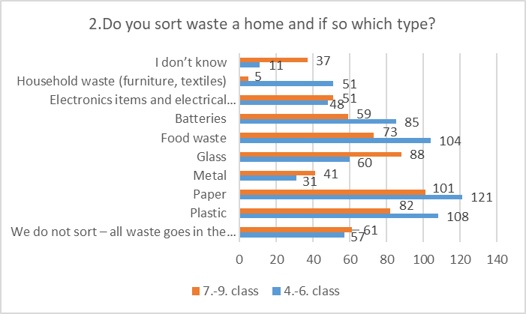

It was possible to choos several answer option.
Almost 24% of students (4.-6. class) do not sort different types of waste at home. About 5% are not aware of whether or how they sort waste at home.
Almost 32% of students (7.-9. class) do not sort different types of waste at home. About 19% are not exactly aware of whether or how they sort waste at home.

3.Do you think waste of any kind can be a valuable resource?

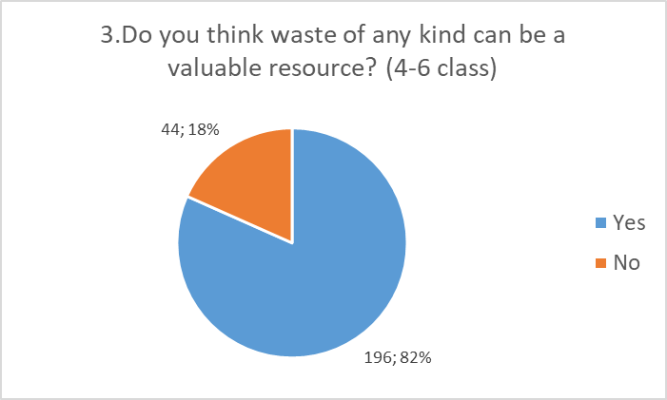
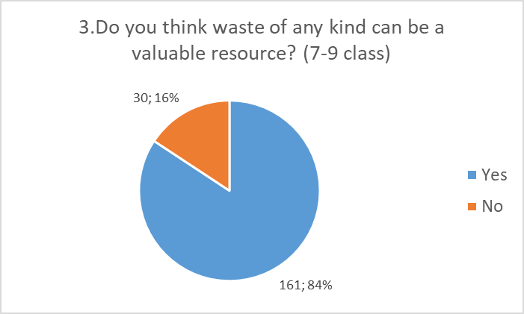

4. What can be made out of waste? (Circle all that apply)

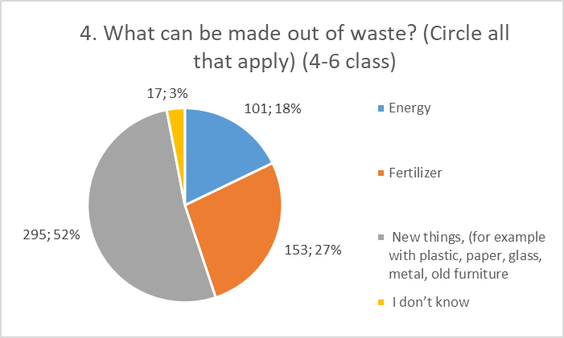
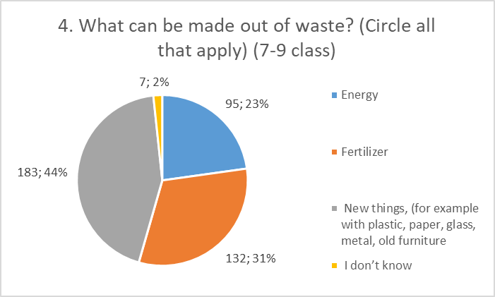

PART II

1. What tipe of residence do you live in?
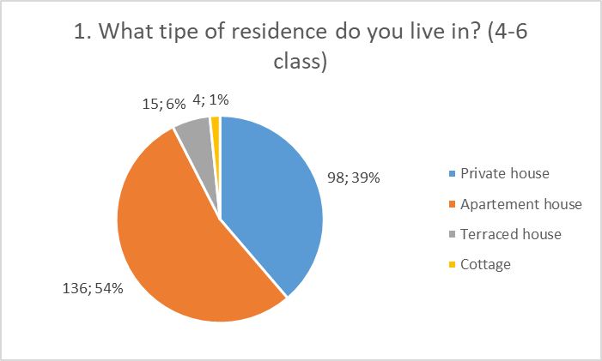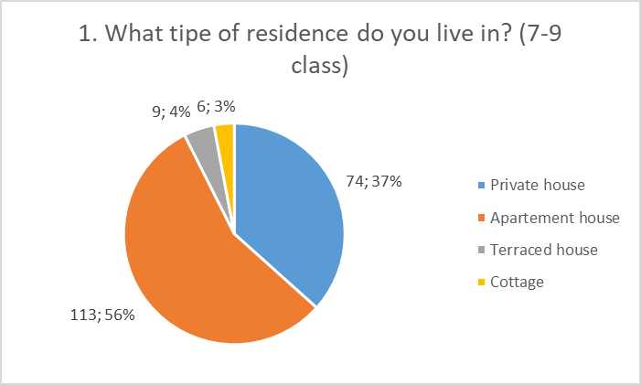

2. Do you reuse?

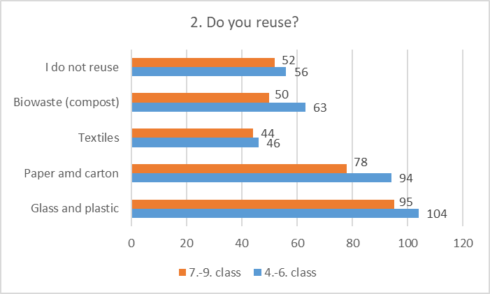

Almost 15 % of respondents do not reuse at all. Altogh almost all knows that things are reusable and important and 82%-84% belive that waste is valuable resource.

3. Have you ever visited any landfill/recycling centres? (4-6 class)

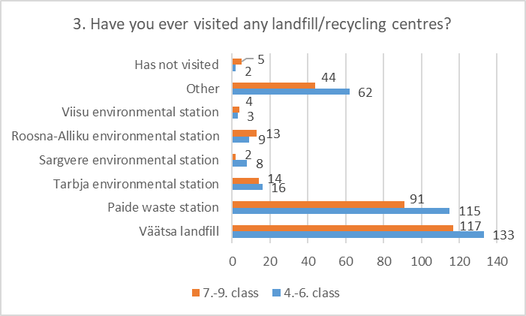

4. Do you know what kind of waste needs to be returned to the waste station (special/hazardous)?

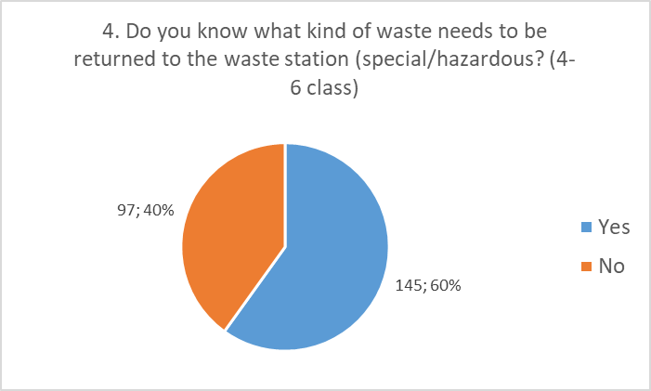
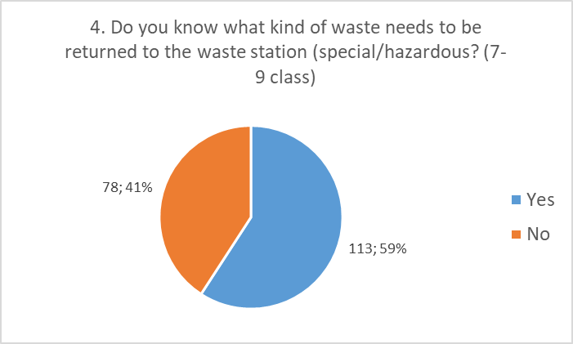

5. If yes, how often do you need to take the waste to the landfill.

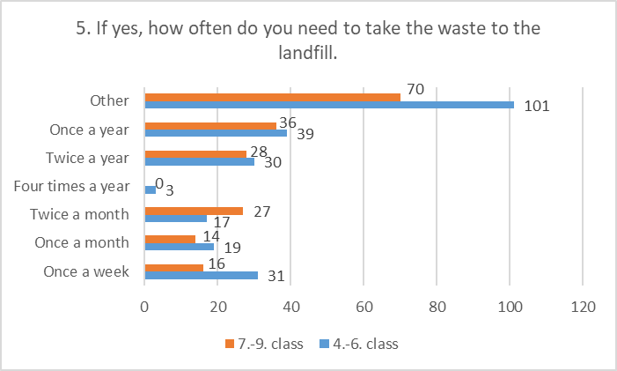

Under “Other”, the answer was mainly that the respondent does not take the waste to the waste station himself, or the respondent does not know how often the waste is taken to the waste station in their family.
Belivebly most answers were given not knowing the diferents of self takeing waste to the landfill and by garbage company.

6. Is the topic of recycling and reusing taught in your school?

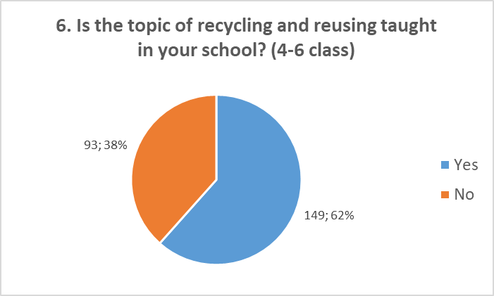
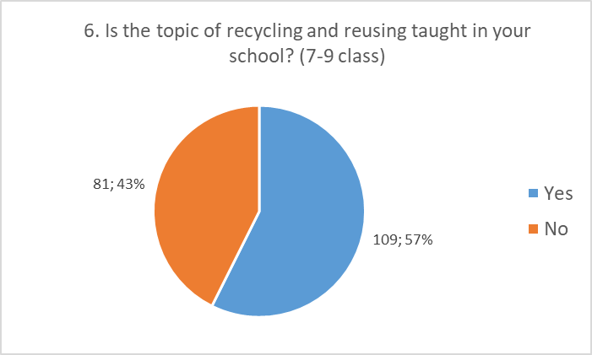

7. Do you use separate containers in your home to separate waste?

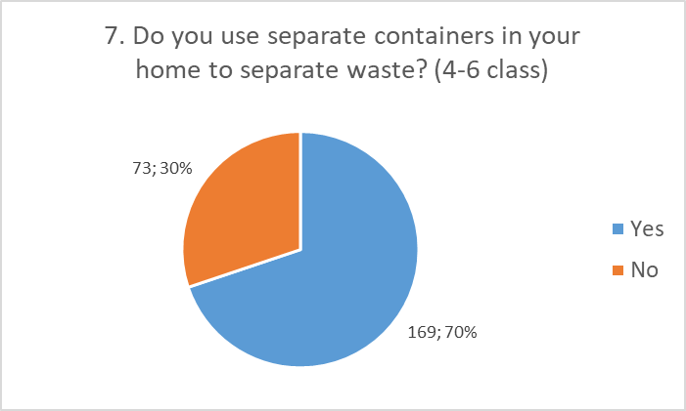
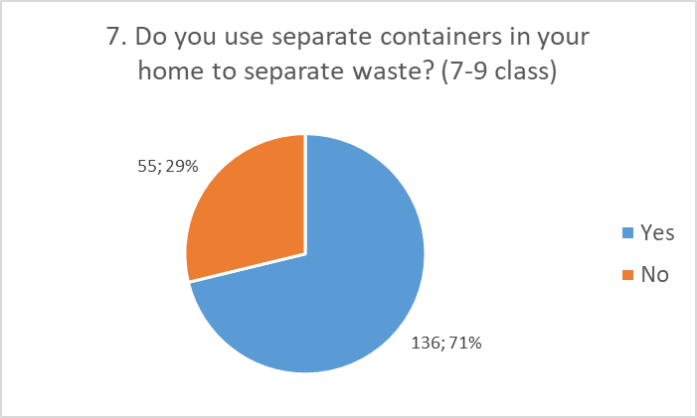

8. If not, why not?

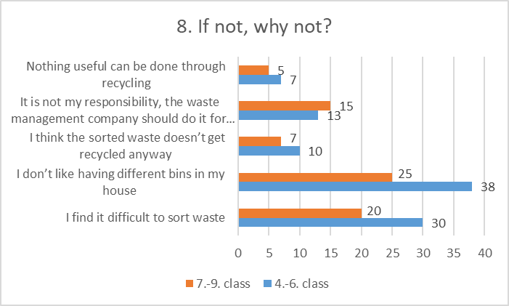

9. Is there anything preventing you from recycling?

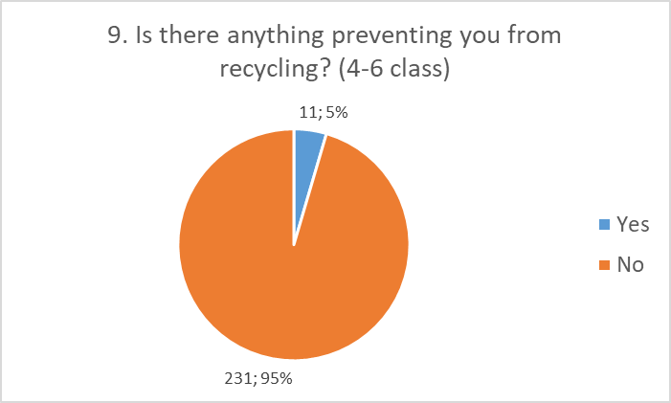
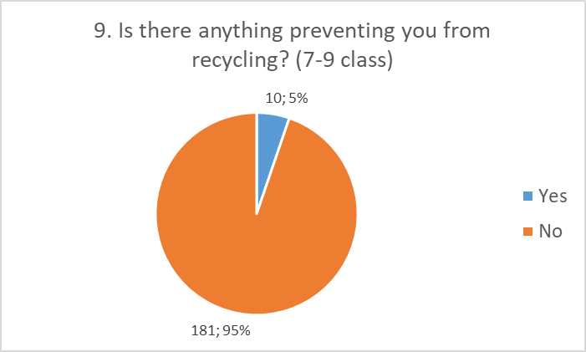

10. If yes, what?
The following answers were given:
4-6 class
- takes too much time;
- I don't have many trash cans and we don't have room;
- I don't like to mess, so I sort about once a week;
- I usually use old cardboard to make crafts and no one forbids me to do it;
- I do not understand the different containers;

7-9 class
- We can't hold 4 trash cans anywhere
- There is no bio-waste container
- Don't bother
- Living in an apartment building and a quick life
- No transport.

- Textile waste, old worn clothes are not to be taken anywhere

11. Do you know about the webpage www.kuhuviia.ee?

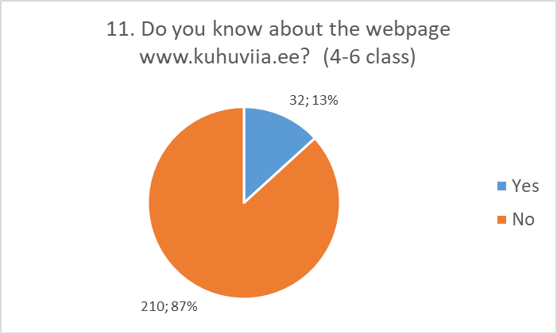
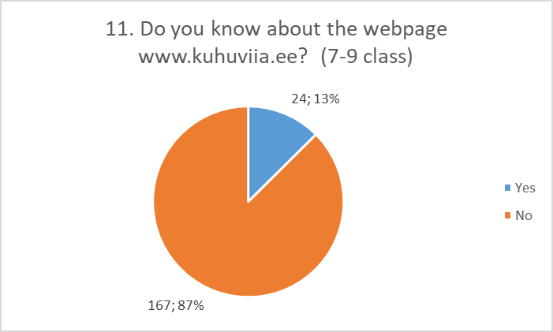

12. If yes, have you used it?

4-6 class
There were 11 students who answered "yes", ie 34% of the respondents answered in the affirmative
7-9 class
„Yes “respondents had 5 students, ie 21% of the respondents answered in the affirmative

13. How would you suggest improving garbage collection and sorting?

The proposals made were as follows:

Class 4-6
- This should be done more frequently;
- Containers at the ends of the house could have labels on them;
- More people could sort; So that everyone sorts the garbage and does not throw the papers down in the yard. All people must keep order; Everyone could sort at least food waste in a separate trash can; People could sort.
- Maybe make a commitment to sort things at least once a month;
- things could be missed so that nothing is left of them;
- There could be more different types of trash; More containers in town
- Removal of waste could be free of charge and everyone could have three boxes at home where waste can be sorted; You will receive a small "reward" for taking the container away, but you will have to pay for taking the waste to landfill. I don't think you should pay for a good deed.
- To transport large waste, you could order a truck that would pick up the waste. (e.g. furniture, old wood, etc.); there could be a website where you can call someone to take out the rubbish
- There could be some kind of machine that sorts garbage;
- Many advertisements should be made with the words: 'Hello good people! Come bring your garbage to a waste center. Good day!"; Share more information
- Different garbage trucks for different things.
- And there is always the possibility of reusing paper and iron, for example. I think people consume more. We buy things we don't really do anything with. And many waste food and paper. Lift yourself as much as you eat. And it is also possible to write sparingly. It's not that hard.
- I think it could be improved so that in every city there are at least two sorting stations where there are automatic sorting machines there should be about four of them. Where you take this thing, you put it under one thing and he tells you which machine to put it on.

7.-9. class
- Prepare a paper bag that breaks down in the rain but is strong
- self-sorting bin
- People should sort more themselves
- Tell people more about it, make people more aware of recycling, teach at school
- there would be a better system of rubbish bins, for example more modern boxes or, for example, abroad, in the stairwells of an apartment building there is one / several pipes (plastic, paper and cardboard, bio-waste) from which rubbish is dumped .
- make it somehow easier and make it less expensive to transport waste.
- Free shipment of sorted waste. Unsorted waste for a fee.
- There could be more sorted waste containers that are not very far from people's homes.

