Within the framework of the project Circular-Based Waste Management (The project is funded by Iceland, Liechtenstein and Norway through the EEA and Norway Grants Fund for Regional Cooperation), a survey was conducted among the residents of the city of Paide between 01.12.2020-28.12.2020.
The aim of the survey was to find out the residents' awareness of waste sorting and recycling.
A total of 126 respondents took part in the survey (ie 1,2% of the total population).

The questionnaire was published on the website of the city of Paide, on the Facebook page of the city of Paide and in the city newspaper of Paide.

Participated in the survey:
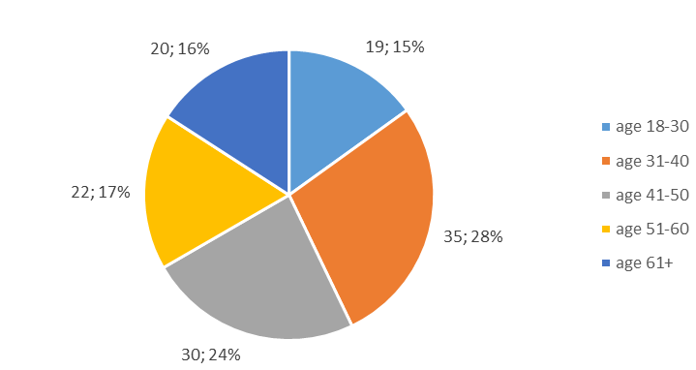

The answers were:
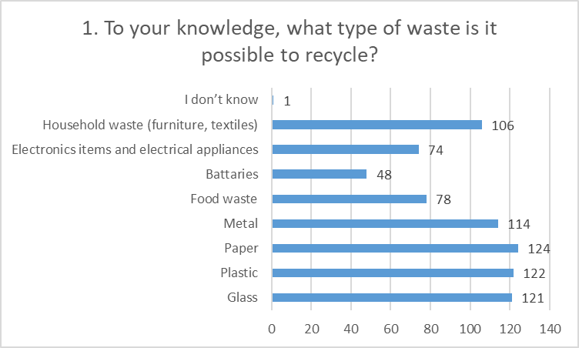
It was possible to choose several answer option

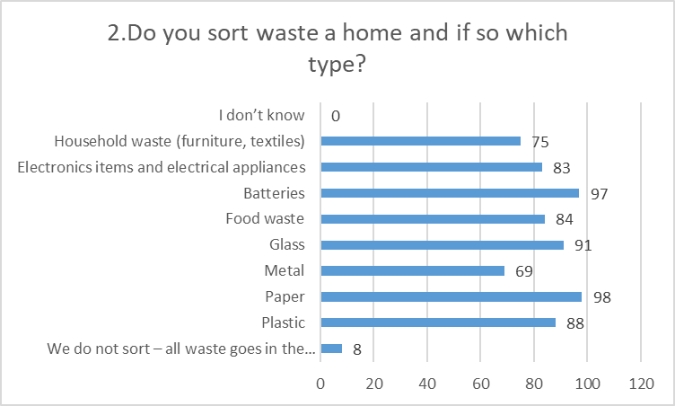

It was possible to choose several answer option

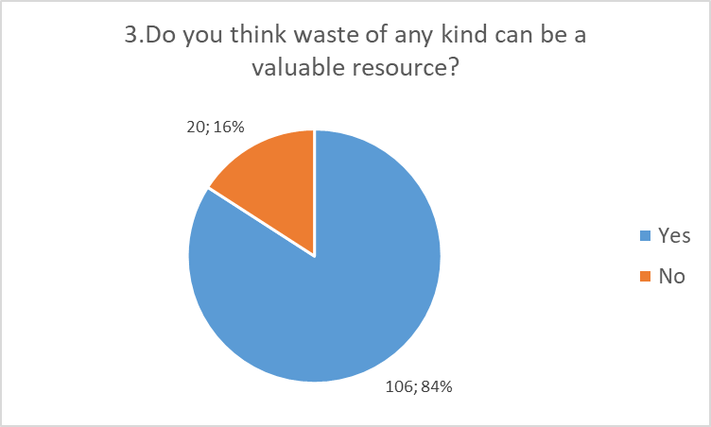

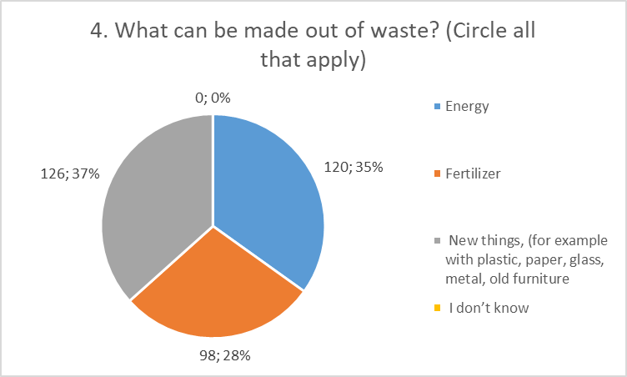
It was possible to choose several answer option

PART II

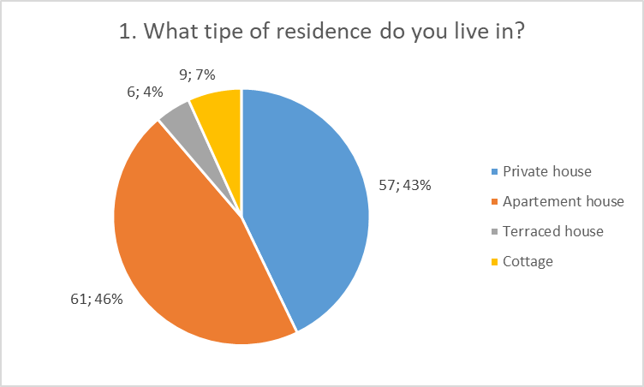
It was possible to choose several answer option

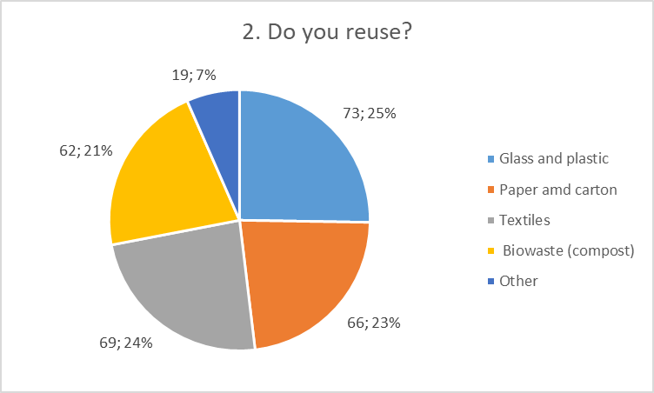
It was possible to choose several answer option

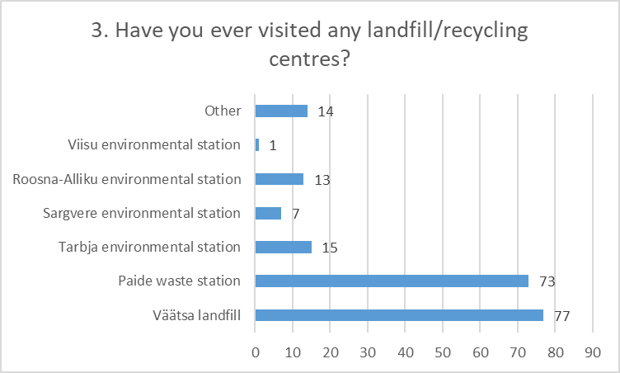
It was possible to choose several answer option

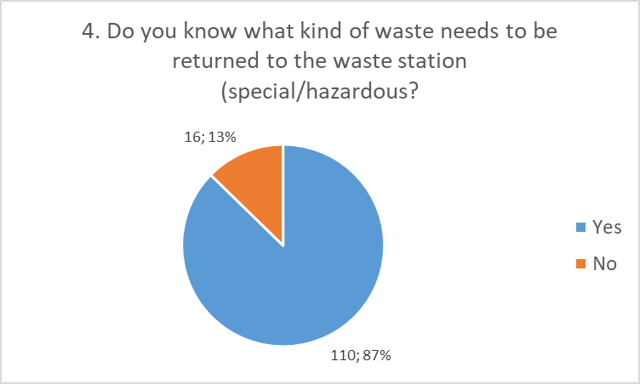

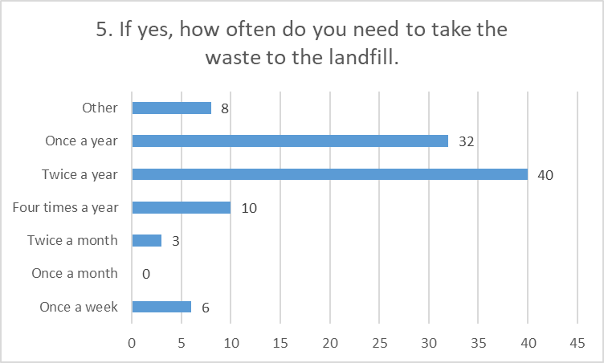

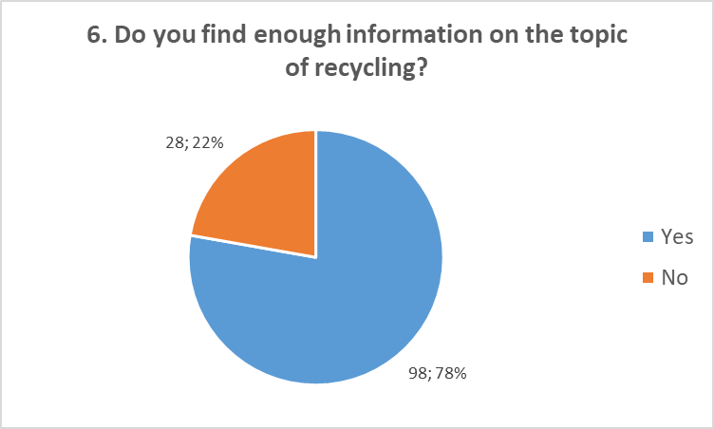

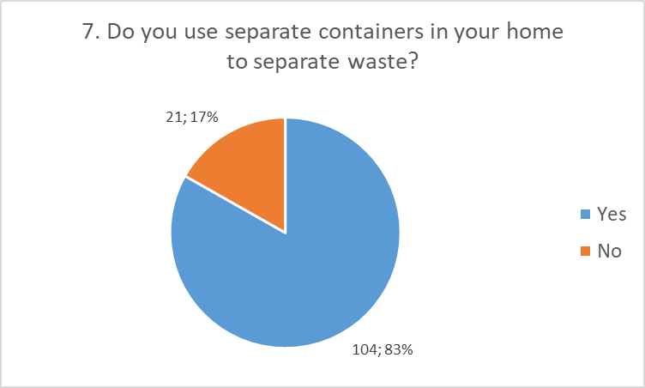

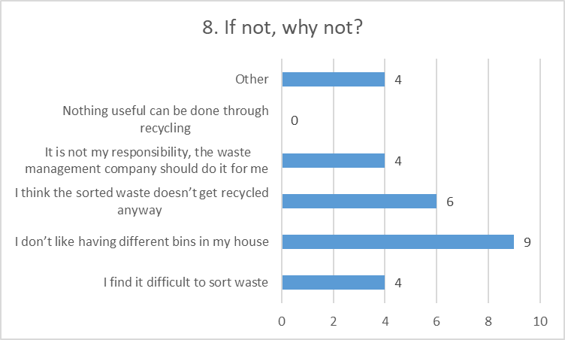
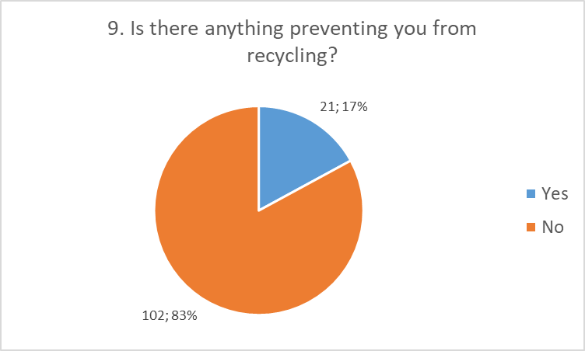

10. If yes, what?
The following answers were given: (The answers are uncganged)

- For some things you don't know how to sort. There is also no space in the apartment.
- There are no public containers for cardboard and paper, as well as for fish, in the village
- I was in Portugal for a while and there is a local government to do that on the corner of each street there are a number of 5-6 different assortments for metal garbage containers that are emptied. Each container is a different color, with pictures of the assortment to be stored there. People use it with pleasure and for the first time I separated 5 different assortments myself.
- garbage containers are emptied sloppily, all unsorted go into the box at once
- Insufficient transport capacity. Lack of composting option.
- Since I live in a sparsely populated area, getting to different containers is time consuming. I still do it sometimes but if the containers were closer to the sorter the garbage would definitely be more.
- Lack of packaging containers.
- The removal of the package should be free of charge for everyone
- there are no containers where sorted garbage can be placed
- Sorted rubbish is difficult to get rid of, there could be containers in the city for residents of private houses.
- Time consuming and sometimes annoying
- Lack of rubbish bins and poor information.
- Existence of containers, opening hours of the waste station.
- The apartment building is quite complicated
- There are no corresponding conditions

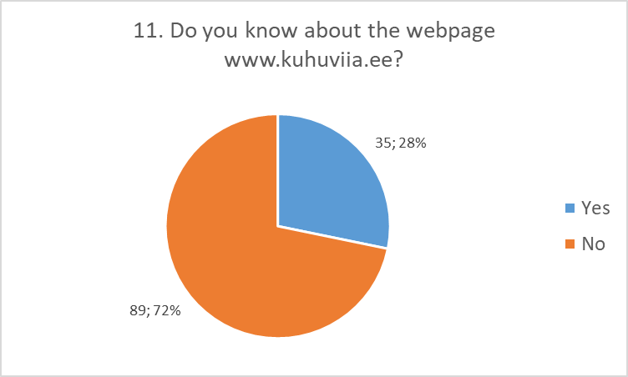
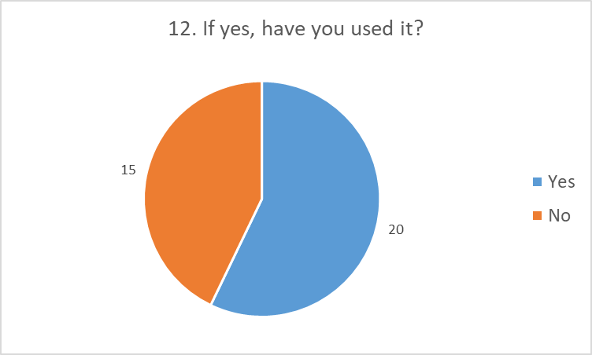
13. How would you suggest improving garbage collection and sorting?
(The answers are uncganged
- Transportation of hazardous waste to city villages; More resources should be allocated to sparsely populated areas
- There could be more information outside the online environment, so that older people and those who do not use this environment would be more aware of what and how. In general, they have a lot of questions. And rubbish bins that are designed to be compartmentalized - cardboard, packaging, glass, etc. could also be physically separate. However, the separate insertion opening is one container ... it does not motivate them very much to sort them, but rather gives the idea that in this way everyone is going to struggle;
- Yellow and blue containers must be emptied more often and washed; More packaging containers or more frequent emptying
- information and information only ... many do not know the possibilities and do not "bother" and do a lot of "extra work" to do so. Make things more comfortable and convenient for people.
- Purchasing containers, concluding contracts with the carrier, etc. is TYPICAL!
- The municipality must provide a different assortment of garbage containers to each side and empty them regularly; The co-operation partner could empty the waste containers more often from the apartment buildings.
- End exemptions from waste shipments (at residences) and introduce a personal waste / pollution tax on which each person's waste shipments have been paid for (in a certain amount). Above the norm, a person must additionally order waste transport himself or herself.
- garbage carriers must be more conscientious and the price of garbage in a situation where it has to be sorted itself is several times lower
- Larger things, such as a refrigerator, sofa, mattress, etc. it is difficult for an elderly person to deliver to a landfill in a rural area. One thing is that there is no such means of transport, another thing, if suddenly someone is willing to tow, then things are difficult and you have to find another pick-up, and how much will it all cost?
- do not see the residents of apartment buildings (especially tenants) with the possibility to change their habits (all in one bag), the price increase would probably not have an effect either. To fine the cooperative, then even those, about 30% (mostly older) residents, may refrain from sorting.
- Increase the price difference (sorted cheaper, mix more expensive); Introduce a common sorting and removal system in settlements (to make removal more efficient). Introduce a uniform sorting system nationwide and popularize it nationwide (public authorities, schools, incentives for the private sector in case of sorting - make the innovative system self-evident), ensure that the information reaches the entire population clearly.
- Small town packaging containers could be emptied more often because they are often too full.
- I don't, but some people put everything in a mixed household trash can.
- The consumer often fills the packaging as well as the cardboard container and then puts these things in the normal rubbish bin. The children dispose of the container here, because they do not take it to Paide themselves and there is no possibility to hand over the container on the spot;
- More placement of special containers. Especially in large companies - hotels, vocational school, etc.
- Containers could be in every settlement (including villages). There is often a situation where you drive to a container with specially sorted garbage, but it is full.
- Bring containers closer to people so they don't have to walk around the city with garbage bags. Closer emptying of containers, because unfortunately when the container is full you still throw the rubbish in a normal container even though the rubbish has been sorted.
- Various collection containers are installed in the centers.
- Removal to support sorting for each private dwelling.
- For some reason, the separate collection boxes are constantly full. are people too aware or what?
- Construction of proper waste stations, separate collection at the door.
- Larger containers should raise people's awareness of sorting.
- Packaging marking system (to know in which container to throw the thing). Sorting could be mandatory in institutions, offices and offices.
- landfills should regulate it and not tax it.
- Packaging containers are far away; The different containers could be located more compactly together so that you don't have to take out the garbage in three different places. Each container is located in a different area in a residential area.
- Sorted garbage containers for residents of private houses.
- Cameras up and monitor that everyone sorts.
- There could also be separate containers for clothes and textiles in the areas of larger apartment buildings;
- Pledge for as many packages as possible (eg jars).
- More information.
- There should be strict regulation at national level and more containers.
- Removal could be more frequent in some places. Biodegradable garbage bags, for example, could also be better available.
- There could be more different containers. After all, a few kilos of metal objects, for example, will not go anywhere to the waste station.
- Perhaps apartment buildings would also need a separate container for electronics.
- It could be like abroad (Belgium). Garbage bags of different colors on sale and standard days of the week on garbage circles. At least in larger populated areas.
- Payment on a volume basis. More and more free collection points for recyclable materials. The penalty for getting rid of the wrong garbage is harsher.
- The layout of containers could be more well thought out in residential areas.

